Product Description Wood-Plastic Composite  Dimension 7 in x 48 in  Thickness 6.5 mm  Wear Thickness 0.5 mm 20 mil  Color 6 Available  Planks / Carton 10  Square / Plank 2.33 | 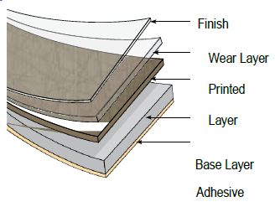

Fire Resistance | Class C – Pass | ASTM 648
Coefficient of Friction | Pass | DIN 51130 / ASTM D2047-04
Smoke Density | Pass | ASTM E662-09
Short Term Indentation | Pass | ASTM F1914—98
Static Load | Pass | EN 433 / ASTM F970-07
Stain Resistance | Pass | ASTM F925
Peel Resistance | Pass | EN 431
Shear Resistance | Pass | EN 532
Color Fastness to Light | Pass | EN 649
Dimensional Stability | Pass | EN 434
Wear Resisistance | High | ASTM F510-93
Formaldehyde Emission (air) | None Detected – E1 Rating* | EN 7171-1
* E1 Standard not to exceed 0.124 mg/m3 air
* Method Detection Limit 0.080 mg/m3 air

