Product Description Luxury Vinyl Tile  Dimension 6 in x 36 in  Thickness 2.0 mm  Wear Thickness 0,2 mm 8 mil  Color 14 Available  Planks / Carton 24  Square / Plank 1.5 | 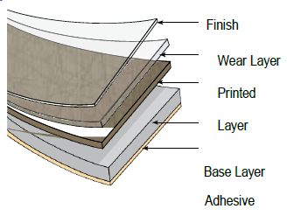

Fire Resistance | Class C – Pass | ASTM E 648
Coefficient of Friction | Pass | DIN 51130 / ASTM D2047-04
Smoke Density | Pass | ASTM E662-09
Short Term Indentation | Pass | ASTM F1914-98
Static Load | Pass | EN 433 / ASTM F970-07
Stain Resistance | Pass | ASTM F925
Peel Resistance | Pass | EN 431
Shear Resistance | Pass | EN 532
Color Fastness to Light | Pass | EN 649
Dimensional Stability | Pass | EN 434
Wear Resistance | High | ASTM F510-93
Formaldehyde Emission (air) | None Detected – E1 Rating* | EN 7171-1
* E1 Standard not to exceed 0.124 mg/m3 air
* Method Detection Limit 0.080 mg/m3 air

